Tennessee Businesses for the Better
Recognizing Smart Businesses Doing the Right Thing for Tennessee
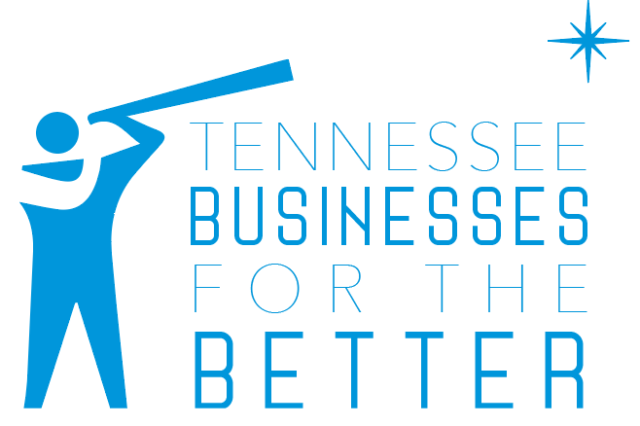
What are Tennessee Businesses 4 the Better?
Tennessee Businesses for the Better (TNB4B) are companies that have taken small steps to service a big group of customers: Tennesseans with disabilities.

In this new statewide recognition initiative by the Tennessee Disability Coalition, TNB4B lauds the work of these select businesses for their smart and inclusive approach to business.

With over one million Tennesseans having some type of disability, it isn’t just the right thing to do. It’s the smart thing.

What does it mean to be “inclusive?”
The very core of any inclusive business practice? The practice of hospitality. The feeling of being welcome and supported is universal to those with and without disabilities.

And the smart businesses know it.

Inclusive businesses make hospitality a top priority for all customers, including customers with disabilities. With roughly 25% of Americans having a visual, physical, cognitive, or auditory disability, every business in the country has customers with some form of disability.

It only makes good sense to help them feel welcome.

The same is true of your current or potential employees. Today’s talent market is more competitive than ever. Making sure your company has an inclusive, hospitable business plan helps ensure your company’s ability to recruit and retain top talent.

From having braille on restroom signs for visually impaired customers to providing a flexible schedule to accommodate an employee’s healthcare appointment, there are countless small things companies do to make their business more inclusive and often more profitable in the process.

What will my business receive in return?
When your business develops an inclusive business practice, the community will start to take notice and you’ll start to gain more than lifelong customers. You'll gain loyal brand advocates who are eager to share information about your company with other potential customers.

Employees with and without disabilities appreciate efforts to create a more inclusive work environment. When employees have the supports they need and succeed in their work, other employees take notice and morale increases. When morale increases, all employees are more successful at their jobs and everyone wins.

Can My Business Be Recognized Too?
Yes! There are many ways to get involved with TNB4B and the Tennessee Disability Coalition.

- Educational Consultation – If you’re wanting to start making inclusivity a priority for your business, we offer private consultations with your leadership team on how to best include customers and employees with disabilities beyond basic ADA requirements.
- Feature Interview – If your business or company is already successful at embracing inclusivity, we’d like to interview you and showcase your business to Tennesseans. We will highlight your business either through a video or written feature and publish the feature on our website and social media.

- Advocacy Engagement – If you’d like to be a part of our advocacy efforts towards public policy that affects Tennesseans with disabilities, we invite you to join us. We provide toolkits on how you can engage customers on policy issues, speak with legislators and more.

Ready to Be More Inclusive?
If you’d like to learn more about Tennessee Businesses for the Better and how your business can be more inclusive, contact us at coalition@tndisability.org.

