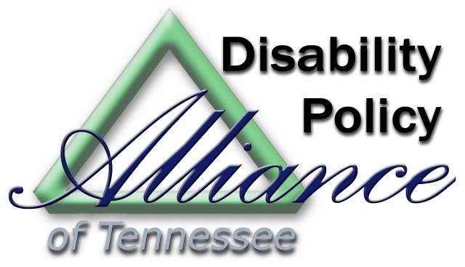

**WELCOME TO DISABILITY DAY ON THE HILL**

**February 14, 2018**

*The Disability Policy Alliance* Welcomes You to a*

*Panel Discussion on the State of Disability Services in Tennessee-*

*and How Your Advocacy has an Impact*

***Capital Building - Old Supreme Court Room 10:00am-11:45am***

1. 10:00-10:05am - Introduction of the Program Moderator – Disability Policy Alliance
2. 10:05-10:15 am – Welcome and Introduction of Panel Members – Jeremy Norden-Paul, Department of Intellectual and Developmental Disabilities
3. 10:15-11:15am – Moderated Panel Discussion with Policymakers and Advocates

Featuring Leadership from: The Department of Education, Department of Intellectual and Developmental Disabilities, Division of TennCare, Vocational Rehabilitation Services, Department of Mental Health and Substance Abuse Services, a Parent Advocate and Self-Advocate

1. 11:15-11:30am – Remarks from Legislators

Featuring Representative Sam Whitson (R-Franklin) and Representative Darren Jernigan (D-Old Hickory)

1. 11:30-11:40am - Q&A with audience
2. 11:45am - Wrap-up by Disability Policy Alliance

*\*The Disability Policy Alliance of Tennessee is a collaboration of the following organizations:*

cid:image003.jpg@01D2765B.98D19820 cid:image005.png@01D2765B.98D19820 cid:image004.png@01D2765B.98D19820