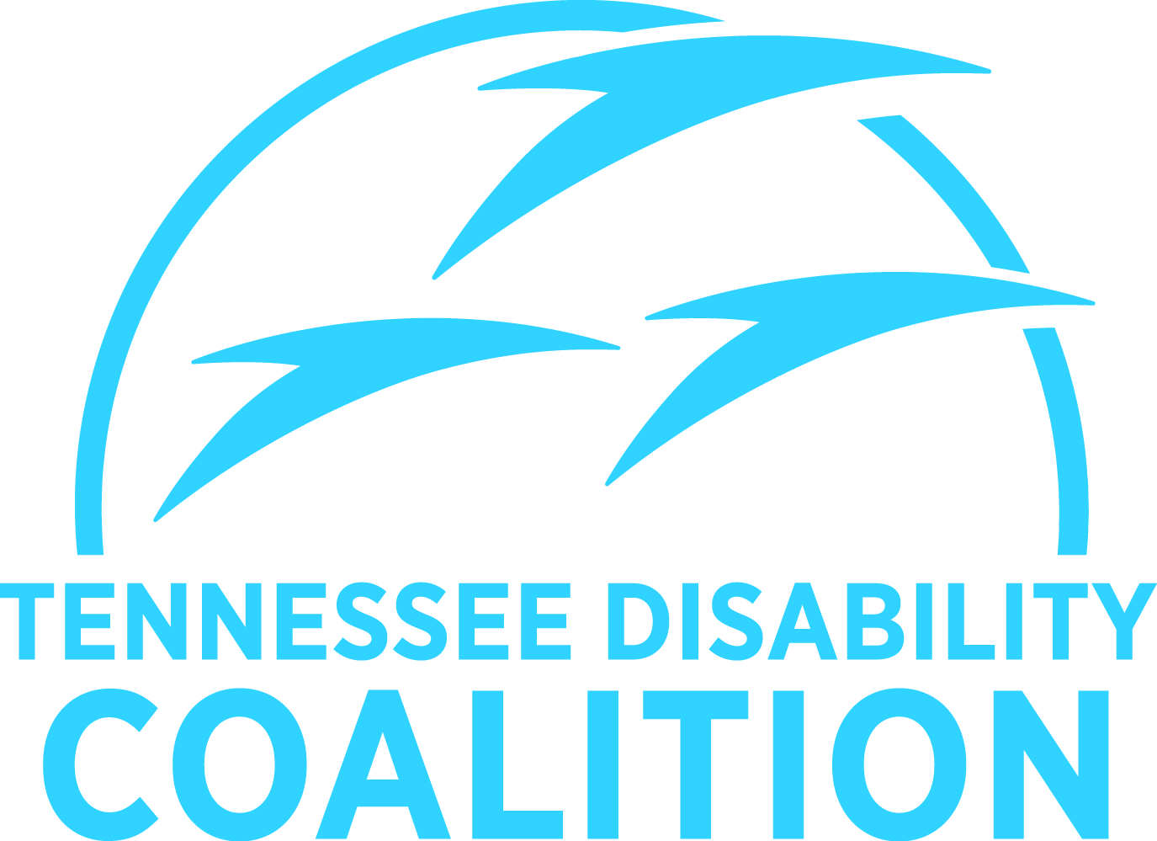
Quick Facts: Family Support Program

The Tennessee Family Support Program is administered by the Department of Intellectual and Developmental Disabilities (DIDD).

More than 4,500 families receive Family Support each year, and the waiting list is nearly as long.

With an average of only $1,387 provided to individuals, Family Support is the least expensive of all programs that provide home- and community-based services. It is funded by state dollars and does not receive a federal match.

The program is locally run, guided by volunteer councils.

Services are provided in all 95 counties by private nonprofit agencies that receive a small state funding allocation. Communities often supplement state dollars with local in-kind services and supports.

Since 1992, this program has been helping to keep families together and members with disabilities in their homes.

The primary purpose of the program is to support:

- Families who have school-aged or younger children with severe disabilities
- Adults with severe disabilities who choose to live with their families
- Adults with severe disabilities not supported by other residential programs funded by state or federal funds

Services are flexible and responsive to families and their needs:

- An essential element of the Family Support Program is family and consumer involvement.
- Local and district councils have been established and meet on a regular basis to oversee and provide advice on the distribution of local services.
“The lifting power of many wings can achieve twice the distance of flying alone.”
Phone: 615-383-9442 Email: ddh@tndisability.org
Online: www.tndisability.org

